A Project Report

On

Website “PHOTOGRAPHY SITE”

# Submitted to Punjab Technical University, Jalandhar

**For the degree of B. Tech in Computer Science & Engineering**

# (Session 2021-2025)



**Submitted To:** Ms. Neha Sharma  **Submitted By: Manav Alang**

**Roll. No:** 2129037

**PCTE INSTITUTE OF ENGINEERING & TECHNOLOGY, LUDHIANA**

**Declaration**

I hereby declare that this project work entitled “Photography site-(Photographer)” has been prepared by me during the year 2021-22 under the guidance of **Ms. Neha Sharma**, Department of Computer Science, **PCTE INSTITUTE OF ENGINEERING AND TECHNOLOGY, LUDHIANA** affiliated to PTU, Jalandhar in the partial fulfillment of B. Tech degree prescribed by the college.

**Acknowledgment**

At the very outset, I would like to thank the almighty GOD for showering his blessing & providing me with the courage, motivation & strength to complete my project.

Every Project work demands a lot of hard work, time, patience, and concentration. While working on this seminar, apart from these aspects, I have developed the necessary skills and attitude, which are always required in a professional field. I am thankful to all those who helped me in completing this project.

I express my deep sense of gratitude & indebtedness towards my respected Project In-charge"**Ms. Neha Sharma**", and the PCTE Institute of Engineering and Technology faculty members from whom I have learned the technical skills for the completion of this Project. Without their guidance, I would have found it really difficult to undertake the project work. I would like to thank them for the ever-available, unconditional help & guidance that they made available throughout the project work.

Also, I would like to mention the support system and consideration of my parents who have always been there in my life.

Last but not least, I would also like to acknowledge the encouraging attitude of my friends & other staff members of the P.C.T.E family that helped me to complete the project work.

**Certificate from Organization**

This is to certify that format and quality of presentation of the project report submitted by **Manav Alang**,

As one of the requirements for the degree of

**B. Tech Computer Science and Engineering**

is acceptable to

**Department of Computer Science and Engineering,**

**PCTE, Ludhiana**

**Head of Dept.**

**(________)**

**PCTE Institute of Engineering and Technology, Ludhiana**

**Certificate from Internal Guide**

This is to certify that the project title “SnapAlot” submitted for the degree of **B. Tech Computer Science and Engineering** in the project of **PCTE Institute of Engineering and Technology, Ludhiana** affiliated to **PTU, Jalandhar** is benefited research which is carried out by me and no part of this project has been for any other degree. They have worked very hard and sincerely during this project.

**Project Supervisor**

**Ms. Neha Sharma**

**Faculty, PCTE**

**Ludhiana**

**Contents**

* Introduction to project
* Objectives of Project
* Features of Project
* Study of Existing System
* Study of Proposed System
* Software and Hardware Requirements at time of development
* Site Map
* Module wise description

**INTRODUCTION**

**INTRODUCTION TO PROJECT**

The project deals with the Frontend work of Photography website.

**OBJECTIVE OF THE PROJECT**

The main objective of this website is to present Photography site by using Mainly HTML & CSS.

**PROBLEM IN EXISTING SYSTEM**

As this website is made only using only HTML , CSS & Little JavaScript. It can take limited data from the user and respond to it. This project is only the frontend work on the photographic website with some minor changes.

**SOLUTION TO THESE PROBLEMS**

User interaction can be made easier and more effective by using more JavaScript and backend work, which will be done in future.

**STUDY OF THE SYSTEM**

**Number of Modules**

The system after a careful analysis has been identified to be presented with the following modules:

* **Home Page**   
  The home tab, a neatly built page, offers the opportunity to connect users with other tabs.
* **About Us**

This will display the information about our motive and thinking of our members.

* **Services**

This will display that which types of photography are specially done by the photographer e.g.: wedding, portrait, fashion, travel etc.

* **Works**  
  This button will take you to view or download the photos or work done by photographer.
* **Contact Us**

User facing any type of difficulty or having any queriy can directly contact us by writing his/her name and problem in the complaint section.

**SPECIFICATIONS**

**HARDWARE REQUIREMENTS:**

* 2.8 GHz Processor & Above
* RAM 512 MB & Above
* Hard Disk 10 GB
* Internet Connection

**SOFTWARE REQUIREMENTS:**

* Minimum OS requirement: WINDOWS XP
* Internet Information Server 5.0 (IIS)
* Visual Studio .Net Framework (Minimal for Deployment)
* SQL Server 2000 Enterprise Edition

**FUNCTIONAL FEATURES OF THE MODEL**

As far as the project is developed the functionality is simple, the objective of the proposal is to give the user the required information about a Photographic content. Here you can get the overview and the layout of the site .

**Functional components of the project:**

Following is a list of functionalities of the system: -

To provide correct images required by user

**Objectives of Project**

* Quality Photographs
* Easy Management
* Easy Updating
* Save Time
* Improve Efficiency
* Easy Search and better results

**Features of Project**

1. **Easy Interface:** This site is made of very simple interfaces. Any user with a minimum knowledge of operating the Computer can easily familiar with this site.
2. **Reliability:** Management Software is reliable software. One can rely on the result produced by this site. We try to remove all the errors from it and make it error free but it can be error prone.
3. **Compact Coding:** Management Software is compact and efficient coded software. It is developed with keeping in mind memory space and speed. It uses less memory space and works on increasing speed.
4. **No extra skills required:**  A person needs not to be a computer professional. If a user with little knowledge of the computer can operate this project.
5. **Large capacity:** The storage capacity is very large and the database is centralized.
6. **User Friendly:** We develop software which is very user friendly.

**Project Planning**

Working as an individual implies the need for some common guidelines and standards to be followed. For optimum usage of the available machine time, it is necessary that every session is planned. Planning of project will include the following:

* Understanding the topic
* Modular break-up of the system
* Process logic for each module
* File structure definition
* Documentation

**Understanding the topic**

The field of application as introduced in the project may be a new field. In that case, many technical words may not be clear. So, as soon as the project is allocated to an individual, one should carefully go thru the project to:

* Identify all words and phrases which are not familiar, or which are application-specific
* Understand the logical flow of events in the application

**Modular break-up of the system**

* Identify the various modules in the system
* List them in the right hierarchy
* Identify their priority of development

**File structure requirements**

The structure of the tables has been given, but if you wish to add a field(s) you may do so. Identify a Key field to uniquely identify a record; if a single key field is not sufficient to uniquely identify a record, then a composite key field can be used.

* All the validations can be given in the property sheet when you are creating forms to enter data. You may try new validations if you have time.
* If you need to edit or delete records you must use the Access menu options.
* You will learn more if you go thru the Help and Cue-Cards offered by Access.

**Documentation**

The documentation has to be submitted to the coordinator in the format. The blank report following the case studies is to be filled up, detached from the report and submitted by the given dates. A sample format is:

* Problem statement
* Database design
* Form design
* Validation performed
* Queries used
* Outline of reports
* Problems encountered and how they were tackled
* Suggested enhancements
* Hardware and Software specifications
* Appendix which has all handwritten outlines like form and report designs

**Site Map**

1. Home
2. About us
3. Services
4. Works
5. Contact us

**Module wise description with screen shots**

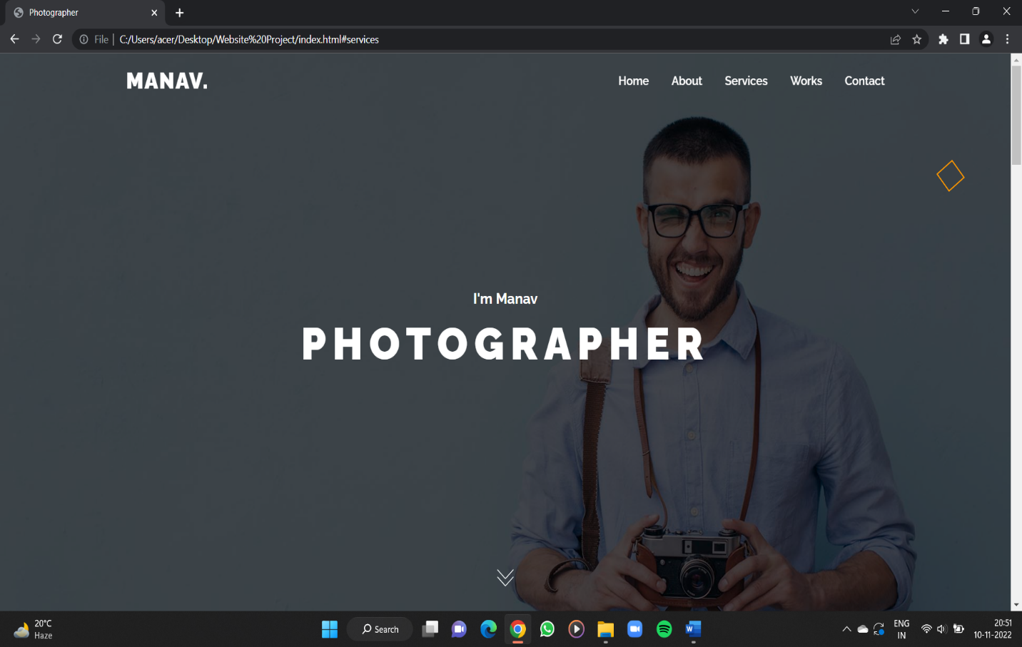

**Page name:** Home page

**Process:** Static

**Stored procedure:** no

**Remarks:** Static

**Error:** no

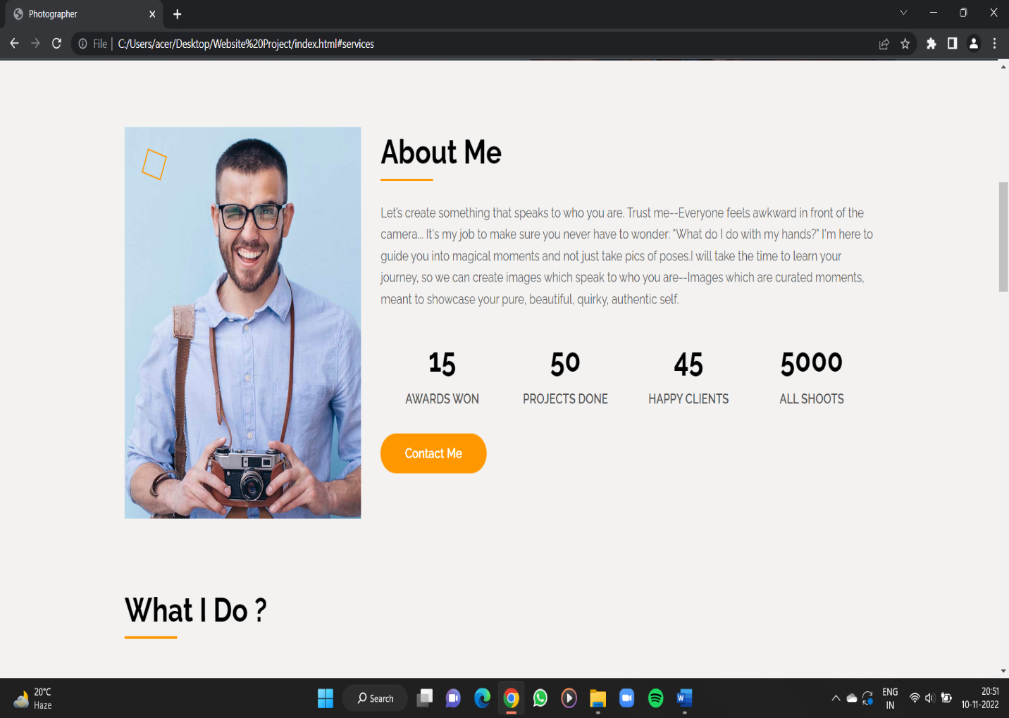

**Page name:** About Me

**Fields:** no

**Process:** Static

**Stored procedure:** no

**Remarks:** Static

**Error:** no

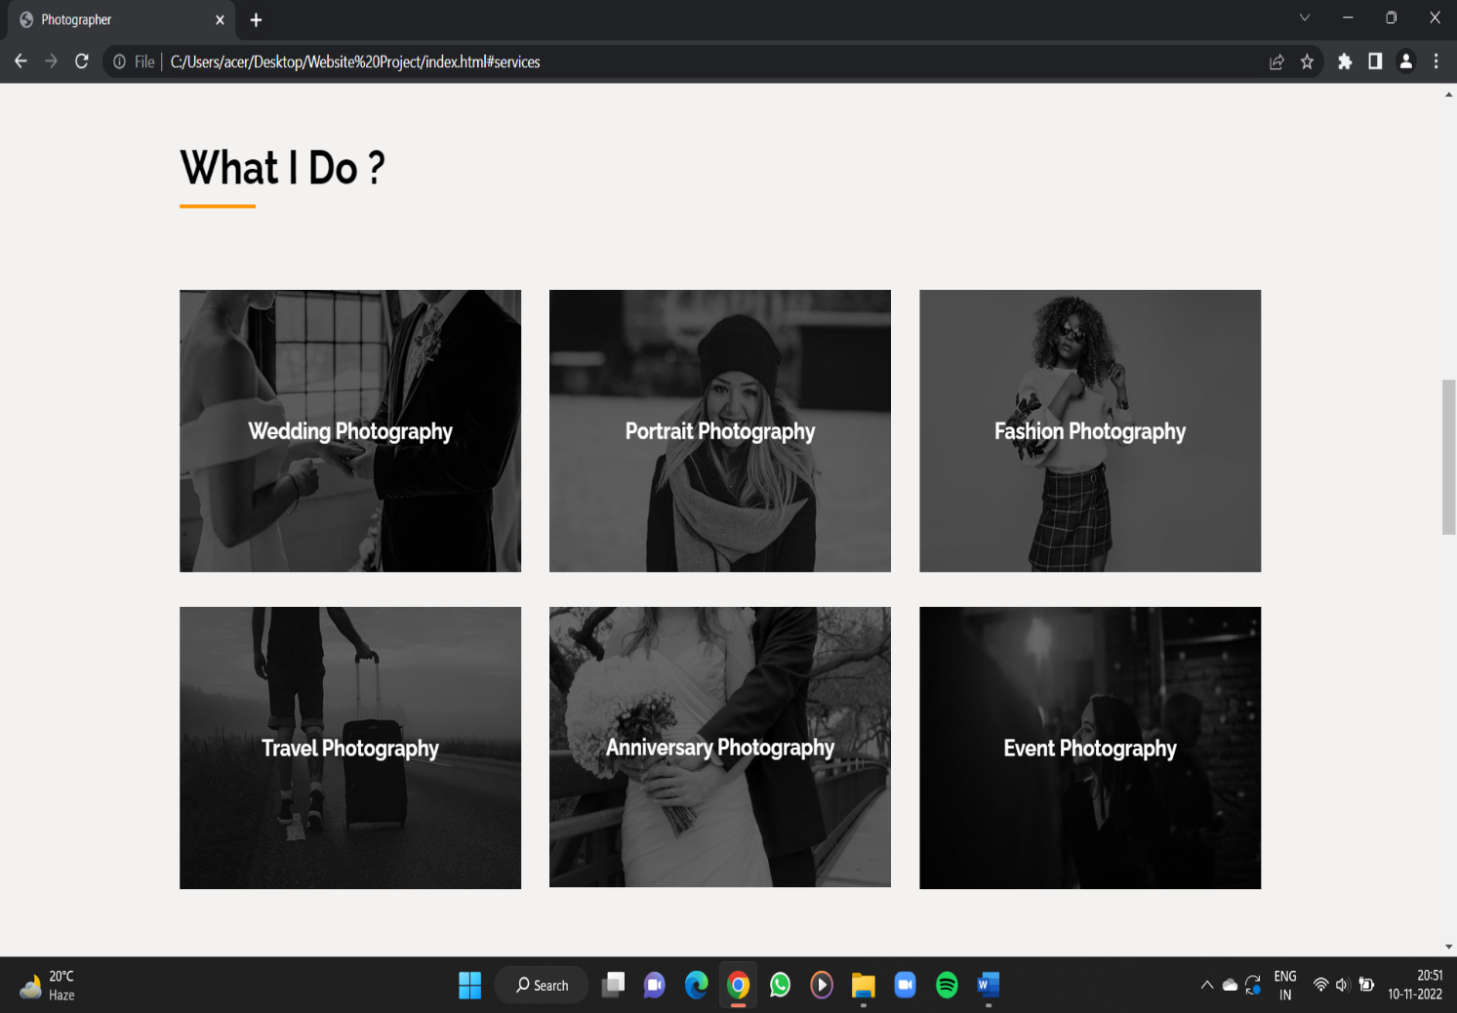

**Page name:** Services

**Fields:** no

**Process:** Static

**Stored procedure:** Photos

**Remarks:** Static

**Error:** no

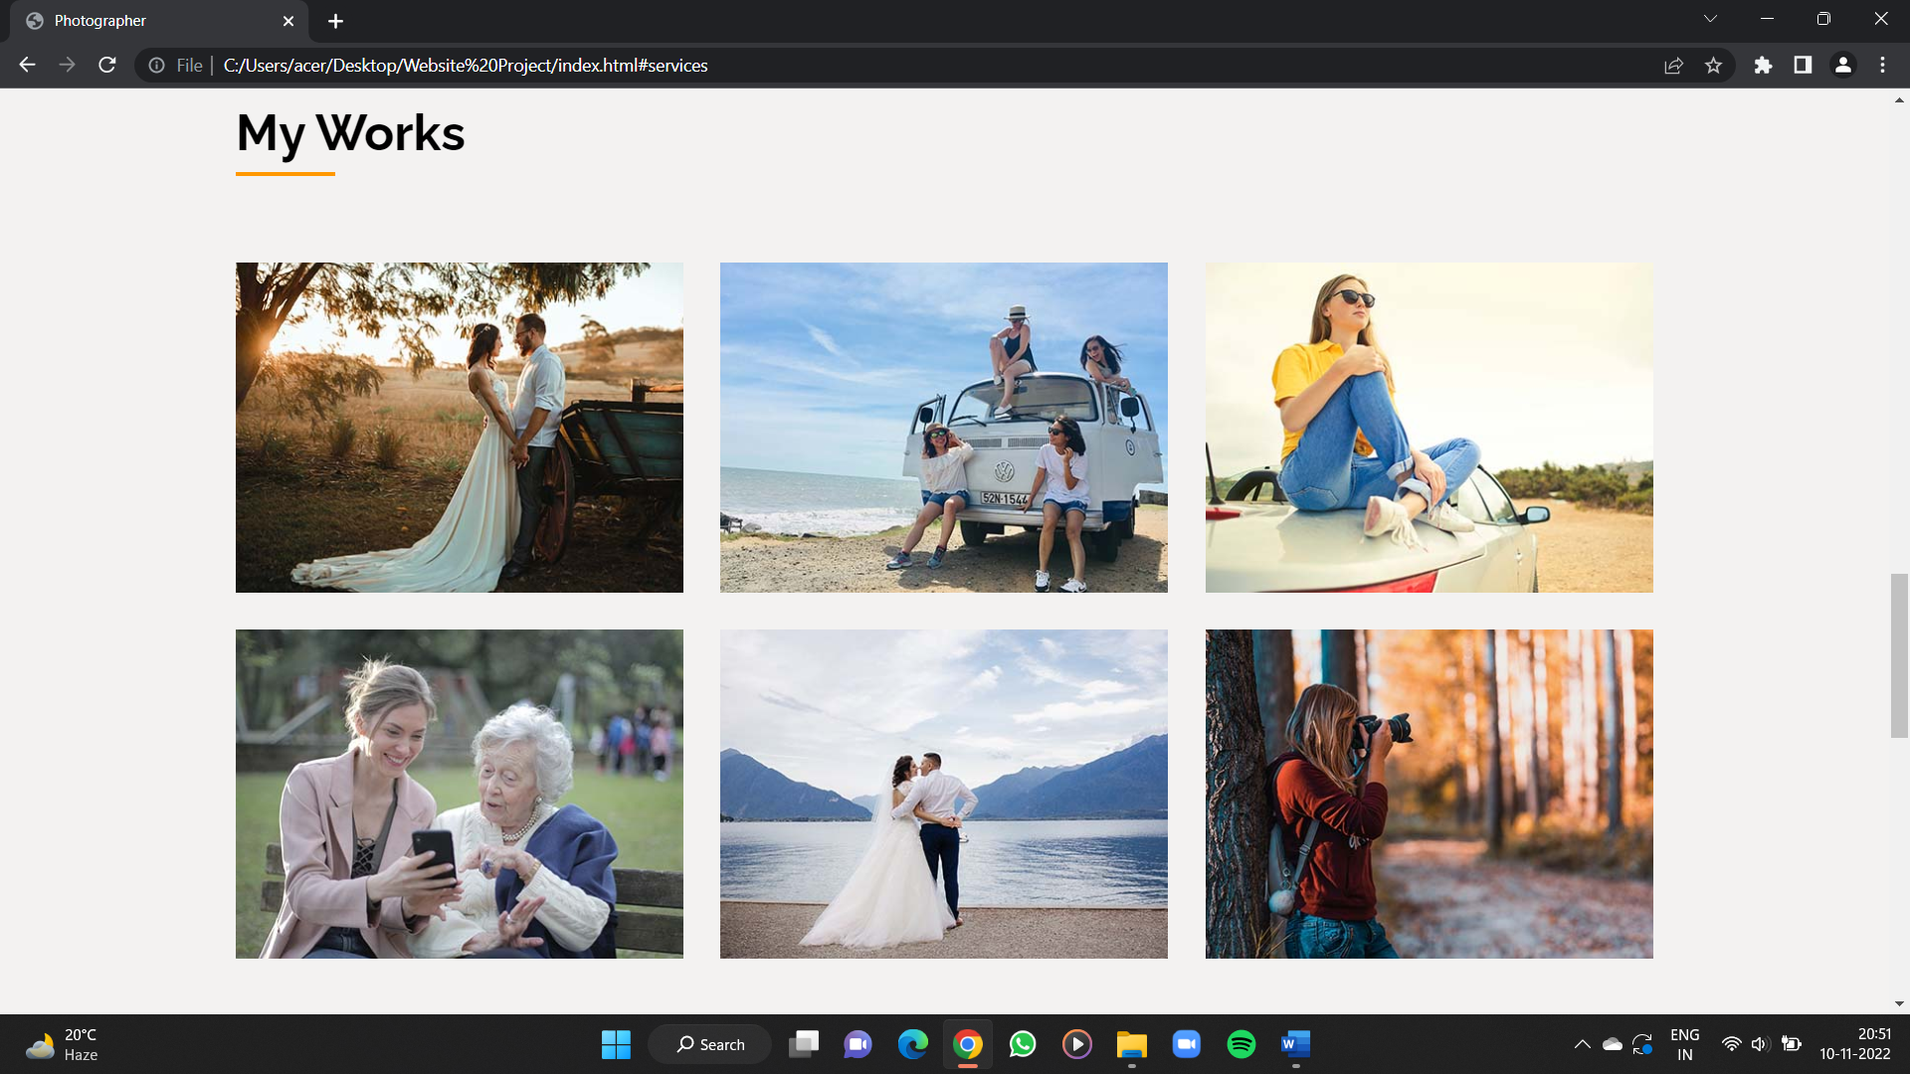

**Page name:** Works

**Fields:** no

**Process:** Static

**Stored procedure:** Photos

**Remarks:** Static

**Error:** no

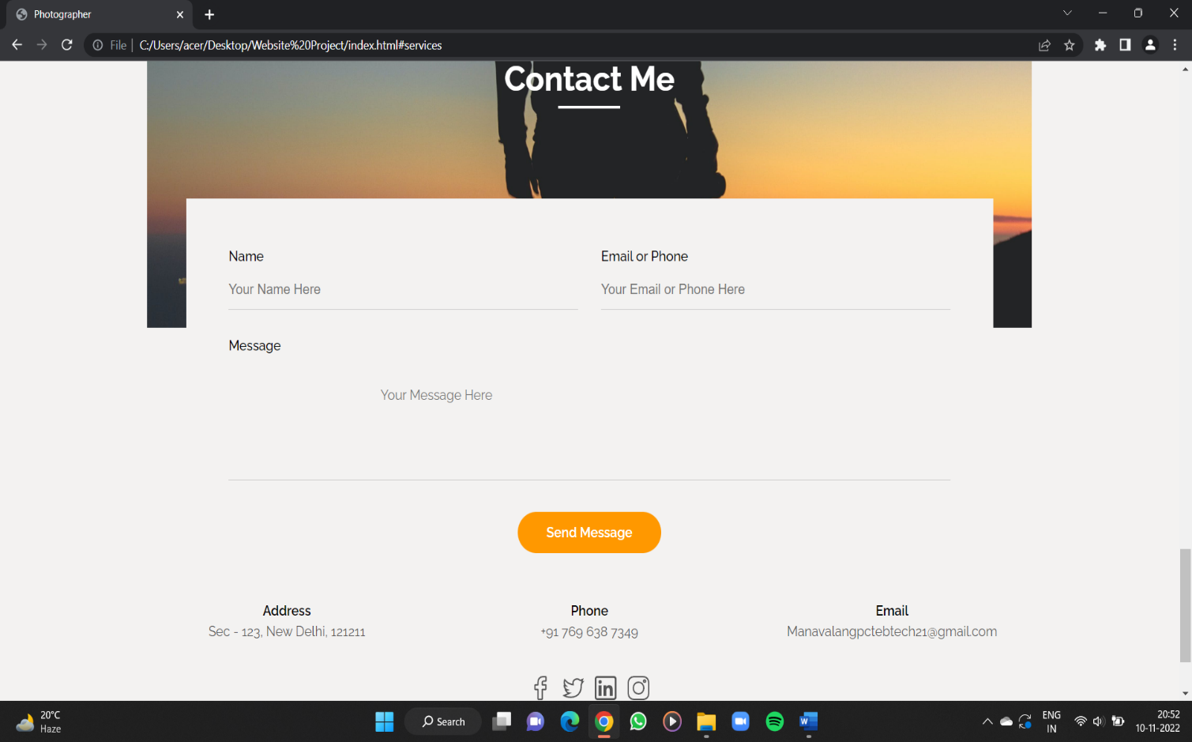

**Page name:** Contact us

**Fields:** no

**Process:** Static

**Stored procedure:** no

**Remarks:** Static

**Error:** no